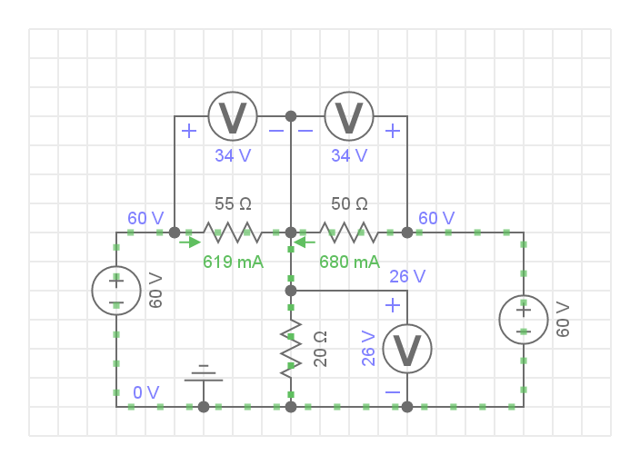

|  |  |  |  |  |  |  |
| --- | --- | --- | --- | --- | --- | --- |
| Calculations | | | Self check | | Excpected | Calculated |
| Name | Formula | Result | E1 | U1+U3 | 60 | 60 |
| R11 | R1+R3 | 70 | E2 | U2+U3 | 60 | 60 |
| R22 | R2+R3 | 75 | PE1 | I1*E1 |  | 40,82474 |
| R12 | R2 | 20 | PE2 | I2*E2 |  | 37,1134 |
| *I11* | (E1-I22*R12)/R11 | 0,6804124 | PE | PE1+PE2 |  | 77,93814 |
| I22 | (E2+R12*I11)/R2 | 0,6185567 | PR1 | I1*U1 |  | 23,14805 |
| I1 | I11 | 0,6804124 | PR2 | I2*U2 |  | 21,04368 |
| I2 | I22 | 0,6185567 | PR3 | I3*U3 |  | 33,74641 |
| I3 | I1+I2 | 1,2989691 | P | PR1+PR2+PR3 | 77,93814 | 77,93814 |
| U1 | I1*R1 | 34,020619 |  |  |  |  |
| U2 | I2*R2 | 34,020619 |  |  |  |  |
| U3 | I3*R3 | 25,979381 |  |  |  |  |

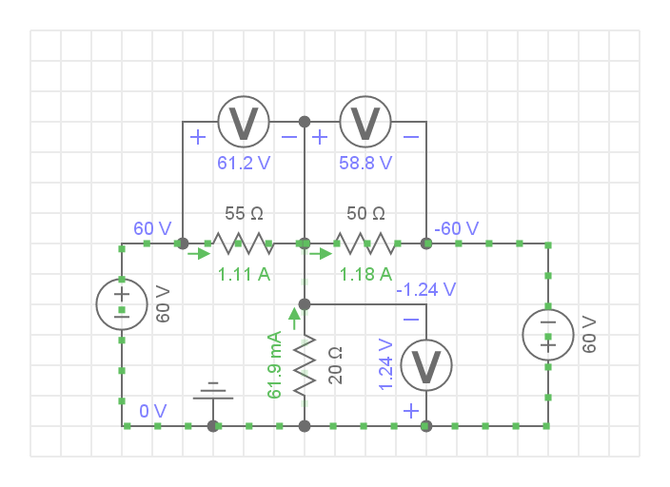

|  |  |  |  |  |  |  |
| --- | --- | --- | --- | --- | --- | --- |
| Calculations | | | Self check | | Excpected | Calculated |
| Name | Formula | Result | E1 | U1+U3 | 60 | 60 |
| R11 | R1+R3 | 70 | E2 | U2-U3 | 60 | 60 |
| R22 | R2+R3 | 75 | PE1 | I1*E1 |  | 70,51546 |
| R12 | R2 | 20 | PE2 | I2*E2 |  | 66,80412 |
| *I11* | (E1-I22*R12)/R11 | 1,175258 | PE | PE1+PE2 |  | 137,3196 |
| I22 | (E2+R12*I11)/R2 | 1,113402 | PR1 | I1*U1 |  | 69,06154 |
| I1 | I11 | 1,175258 | PR2 | I2*U2 |  | 68,18153 |
| I2 | I22 | 1,113402 | PR3 | I3*U3 |  | 0,076522 |
| I3 | I1+I2 | 0,061856 | P | PR1+PR2+PR3 | 137,3196 | 137,3196 |
| U1 | I1*R1 | 58,76289 |  |  |  |  |
| U2 | I2*R2 | 61,23711 |  |  |  |  |
| U3 | I3*R3 | 1,237113 |  |  |  |  |

|  |  |  |  |  |  |  |  |  |  |
| --- | --- | --- | --- | --- | --- | --- | --- | --- | --- |
|  | E1 | E2 | PE1 | PE2 | P1 | P2 | P3 | PE | P |
| Measured | 60 | 60 | 40,82474 | 37,1134 | 23,14805 | 21,04368 | 33,74641 | 77,93814 | 77,93814 |
| Calculated | 60 | 60 | 40,82474 | 37,1134 | 23,14805 | 21,04368 | 33,74641 | 77,93814 | 77,93814 |
| Measured | 60 | 60 | 70,51546 | 66,80412 | 69,06154 | 68,18153 | 0,076522 | 70,51546 | 66,80412 |
| Calculated | 60 | 60 | 70,51546 | 66,80412 | 69,06154 | 68,18153 | 0,076522 | 70,51546 | 66,80412 |